Prime Test Slide Compared to Cytotoxic Test Slide
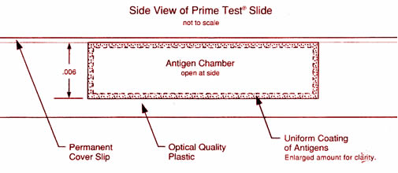
Uniform coating of the antigen is possible because the antigen solution is injected from the side and dries from the side, not from the top. This controlled drying prevents the antigen coating from being too thin in one area and too thick in another. Antigen coeting is on both the slide and the underside of the cover slip. The chamber height is uniformand only 0.006 of an inch, and thus the white blood cell are always within 0.003 of an inch from an antigen-coated surface. Damaging reaction can be clearly seen with a microscope.
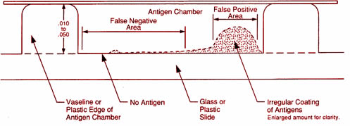
This diagram illustrates typical designs of the original Cytotoxic test. When liquid antigens are dropped from the top and dry on a flat surface they deposit their inrgedients irregulary. Thus, depending on the area studied under the microscope, the cytotoxic tast can report false negatives or false positives.

